THE STATE OF THE ECONOMY AND ECONOMIC POLICY
Testimony before the U.S. Congress Joint Economic Committee
Michael J. Boskin
Tully M. Friedman Professor of Economics and
Hoover Institution Senior Fellow, Stanford University

Washington D.C., February 28, 2013

Chairman Brady, Vice Chair Klobuchar, and members of the Committee, I am pleased to be appearing before you today to discuss the state of the economy, my evaluation of U.S. economic policy, and my suggestions for policies to strengthen economic growth.
The economy remains mired in an anemic recovery from the financial crisis and recession, which was as or more severe than any economic shock since World War II. Unemployment soared, long-term unemployment became entrenched, many more left the labor force, investment plummeted. There were many interrelated causes: the burst housing bubble foremost among them. Two prime causes of the bubble were the serial social engineering of housing and too-loose monetary policy during a boom. Home prices plummeted and housing construction collapsed. The problems spread to other sectors of the economy.
The government undertook unprecedented monetary, fiscal and regulatory responses to the crisis; I believe some were quite helpful, especially early monetary policy, the automatic fiscal stabilizers, and, while done poorly, the capital made available to the banks. Absent those interventions, I believe the downturn would have been worse.
The unprecedented anemic recovery has been almost as damaging as the recession. Usually recoveries from deep recession are sharp and swift, as in the 1970s and 1980s. Sometimes recoveries from financial crises are slow, though not always. The economy remains well below its potential (Figure 1). Economic growth has averaged roughly 2% per year since the recession ended. Last quarter the economy was essentially flat, and this quarter the Blue Chip forecast again calls for anemic growth (Figure 2).

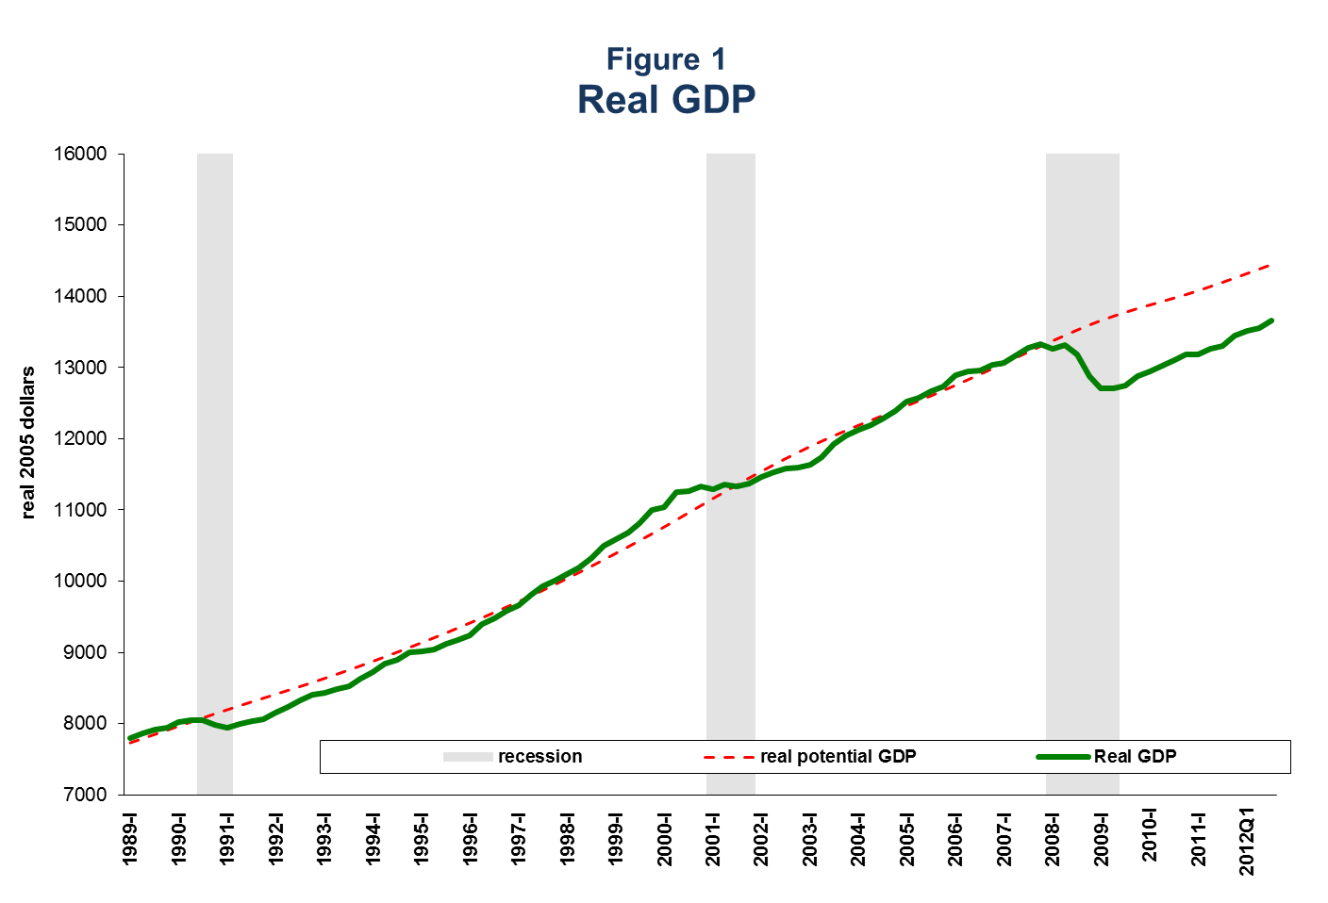
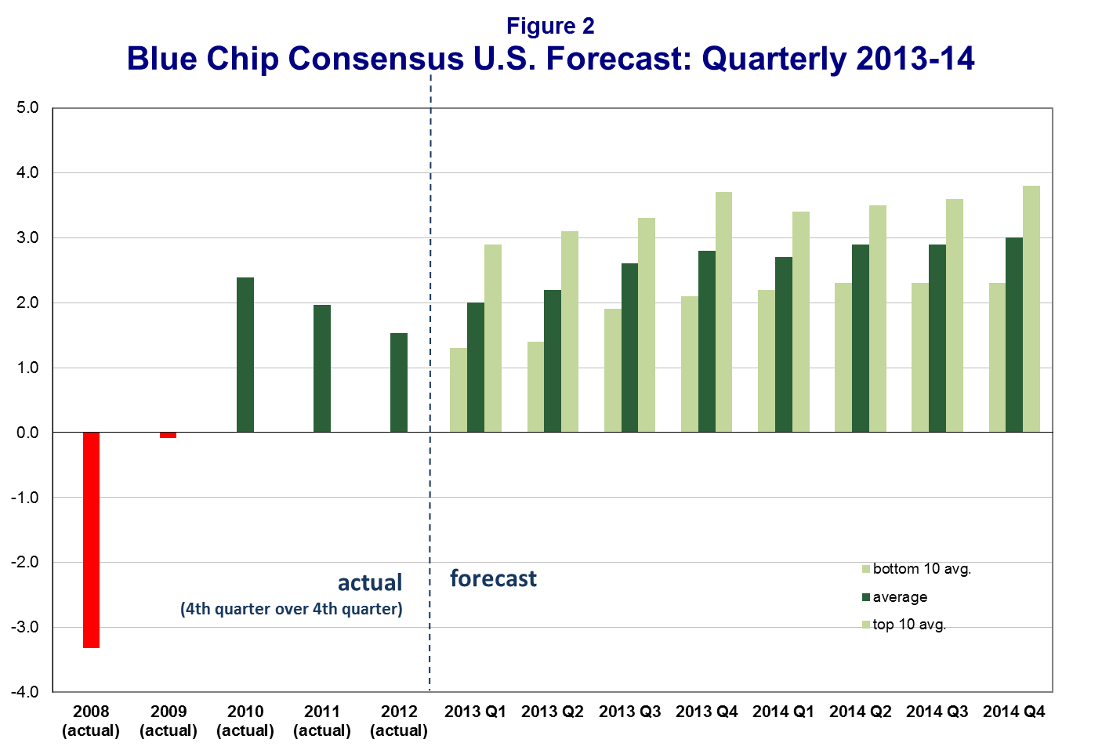
The modestly good news is that these same forecasters project a modest pickup, to a still far-too-low 2.5-3%, this year and next. The CBO has the economy growing at 1.4% this year and 2.5% next; thereafter, 4% for a couple of years. The Administration forecasts a more solid recovery, 2.6% in 2013 and over 4% in 2014.
Every year, the Administration has forecast 4% growth the following two years. Growth has been just half that. So some combination of incorrect interpretation of economic events and unwarranted enthusiasm about the efficacy of its policies led the Administration awry.
I am generally in agreement with the Blue Chip Consensus Forecast as a base case. However, I see considerable risk of doing worse over the next couple of years and some opportunities to do better.
The main risks in the short run stem from 1) fiscal policy, especially any additional tax hikes, and the inability to agree on medium and long-run fiscal consolidation based primarily on slowing the growth of spending; 2) Europe’s deepening recession, which affects roughly 20% of our exports. Its debt and banking crises remain a major problem, not just for Europe but for America and the global economy. Europe’s banks are more thinly capitalized than American banks, but extend a larger share of credit in the economy as compared to credit markets. 3) China, now the world’s second largest economy, is early in a political transition and must deal with a complex array of its own problems; 4) geopolitical issues, e.g. Iranian oil; a worst- case scenario could be severe enough to cause a recession. 5) Continued deleveraging of the private sector, still in middle innings; 6) Still tight credit for small business; 7) additional regulation raising still higher the cost and uncertainty caused by the explosion of regulation in recent years; wide swaths of the economy are being forced into non-commercial decisions by health care reform, Dodd-Frank, and EPA regulation, whatever their noneconomic benefits may be; 8) monetary policy exit risk. The Fed is projected to have a balance sheet of $4T by 2014. QE has hit diminishing returns; still more excess reserves won’t ease bank lending. Boosting asset prices risks bubbles that can burst to serious disruption. The Fed says it will raise interest on reserves to keep the banks from lending too rapidly, which risks inflation. But especially given recent history, it is hard to imagine the public and the Congress sitting by while the Federal Reserve gives, not lends, tens of billions of dollars to banks.
If we are fortunate enough that these risks do not materialize or are ameliorated quickly, there is certainly lots of opportunity for the economy to do better than projected. 1) Housing has finally begun to rebound. Although from a smaller base, it is now adding to, rather than subtracting from, growth; 2) fiscal drag from state and local tax hikes and spending cuts has likely peaked; 3) technology revolution – “fracking” – has created a boom in domestic oil and gas, which is generating jobs, incomes, and government revenues. Combined with greater offshore drilling permits, Canadian oil, and the once-unimaginable possible opening up of Mexico’s oil industry to foreign investment, we have the opportunity to dramatically reduce OPEC’s strategic power. This is not just a potential economic revolution, at least, if policy or unsafe development doesn’t kill it, but one of the most important geopolitical shifts in America’s favor in decades. 4) Lots of cash is available on the sidelines, earning virtually nothing in relatively safe assets, on household and corporate balance sheets. Businesses are waiting for more favorable investment and hiring opportunities in a stronger economy and a more favorable expectation of the future tax and regulatory environment.
To see just how weak the recovery has been so far, see Figures 1, 3 and 4. Figure 1 demonstrates the economy has made up very little ground on its potential. The output gap is still large. This is because the recovery has been so anemic compared to recoveries from the other two deep post-World War II recessions. Those recoveries – in the mid-1970s and mid-1980s – were sharp and strong. As Figure 3 shows, GDP growth in the current recovery has been only 40% as strong. Even worse, the jobs recovery has been running at only a 20% pace. In their first three and one-half years, the earlier recoveries generated, adjusted for the growth in working age population, an average of 14.3 million jobs. The current recovery is 10 million jobs short.

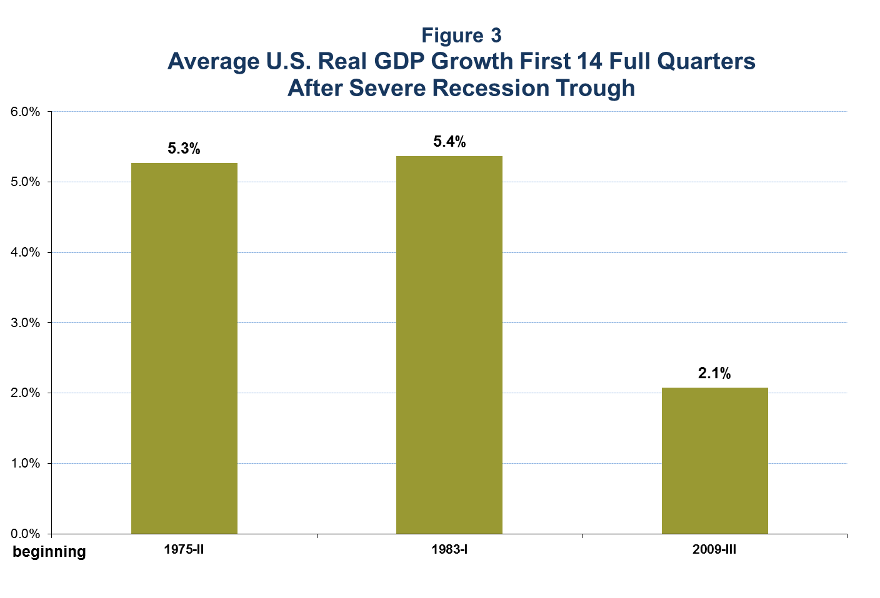
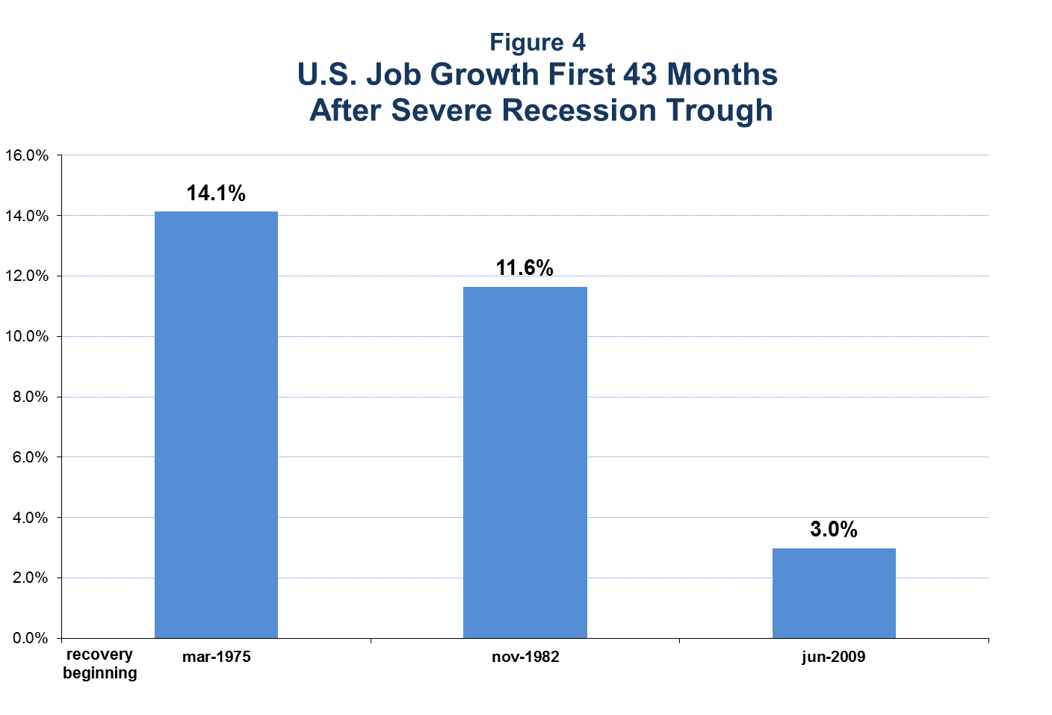
There are undoubtedly many reasons for this poor performance, including continued deleveraging, global economic problems, and others, but some unfortunate policy choices have contributed significantly by raising costs and adding uncertainty to an already uncertain economic environment.
The discretionary fiscal policy response to the recession, while timely, was poorly designed and implemented. There are many studies of its efficacy or lack thereof. Opinions of the net effects of the stimulus bill range from negative to adding 3+ million temporary jobs.
The $825 billion stimulus bill thus cost hundreds of thousands of dollars per job, many times median pay, even on the Administration’s jobs estimate, far more on others. Cash for Clunkers cost $3 billion merely to shift car sales forward a few months; its CO₂ emissions savings cost twenty times the EU carbon trading price. The PPIP program to buy toxic assets from the banks to speed lending generated just 3% of the $1 trillion planned. The temporary, inframarginal tax cuts hardly budged private spending; the analogous, smaller, Bush ’43 2008 tax cuts had virtually no effect on private spending.
And, as the President stated, “the ‘shovel-ready’ stimulus projects weren’t ready’”; (actually, modern public infrastructure projects use large equipment, not many shovels). And Harvard’s Ed Glaser concludes that infrastructure is poor stimulus because “It is impossible to do quickly and wisely.” The nation certainly has infrastructure needs, some appropriately federally financed, but those should be dealt with in the normal authorization and appropriations process. Also, a recession was the worst possible time to try to reengineer large sectors of the economy, from health care to energy to financial services, as the greatly increased uncertainty and prospective higher costs froze investment and hiring.
If these policies had been likely to strengthen short-run growth at reasonable long-run cost, I would have supported them. Unfortunately, the emphasis on short-run, temporary spending increases and inframarginal tax cuts, in combination with the attempted re-engineering, did little, if any, good for the large cost.
Economists long ago concluded that most consumption is driven by expectations of future after-tax income, not current short-run disposable income. And businesses invest for future profits and, hence, are sensitive to expectations of future tax rates. Both the prospects of higher taxes from both legislation and the explosion of debt, plus the added uncertainty were a serious hindrance to short-run, not just future, economic growth. Tax changes expected to be long-lived, especially changes in marginal rates, will have a much larger effect than inframarginal changes that are, or are expected to be, temporary. That’s why the Kennedy, Reagan and Bush ’43 tax rate cuts had large short as well as long-run effects (when finally phased in), and the Bush ’43 2008 and Obama 2009 rebates, and the small payroll tax cut, had comparatively little.
The action I believe would help the economy most in both the short and long run would be a strong, credible commitment to serious fiscal consolidation, phased in gradually as the economy recovers. It should be difficult to reverse, absent a major emergency such as war or recession. That means permanent, structural changes, not just a specific dollar cut, easily reversible in the next round of appropriations. It likely also requires toughened budget process rules on spending and debt.
Pro-growth tax reform -- “lower rates on a broader base “ – can be an extremely valuable complement to spending control. The present discounted value of future taxes must cover the present value of future spending, plus the national debt (net of assets). In short, the government must pay for spending with taxes, now or in the future. So the only way to prevent large tax increases is to control spending growth. Put another way, spending control is also tax reform.
The harm from higher tax rates distorting decisions to work, save and invest rises with the square of the rates. Doubling the rate quadruples its harm. This is not doctrinal; it has to do with the area under supply and demand curves taught in every Introductory Economics course. This is why economists favor broad-bases and low rates. Worse yet, the same economic activity is often taxed multiple times: e.g. wages by federal, state, and local income taxes and payroll taxes.
Especially worrisome is America’s high corporate tax rate (the statutory rate is the highest in the OECD; the effective rate also out of line, but not as far). We should transition to broad-based income taxes with the lowest rates possible to raise necessary revenue, ideally integrating the corporate and personal income taxes.
The potential benefits from stylized tax reform are large. Several studies show income gains of 6+% from comprehensive broad-based low rate(s) consumption tax reform. That is about one-fifth of the difference in per capita income between U.S. and Western Europe. Economists debate what fraction of that difference is due to higher European tax rates and bloated welfare states, from under half to 100%. But clearly, tax reform can be an important effective complement to spending control.
The Long Run
Turning attention to the long run, Americans are more pessimistic than at any time in many decades. Record numbers are doubting that their children’s and grandchildren’s standard of living will be higher than ours. They wonder whether we will ever get back to normal, or are in a new normal of much slower growth or even Japanese-style long-run stagnation. They wonder whether the expansion of temporary programs will become permanent; whether the lurch toward a European-style social welfare state will stop; and if some combination of monetary policy and exploding government debt will lead eventually to high inflation. And the anemic jobs recovery has many wondering if we will ever get back to full employment, or whether it is primarily a cyclical problem or a permanent change in labor markets
Worse yet, the almost-doubling of the debt-GDP ratio since before the crisis, and the prospect of much larger debt and deficits from the explosion of entitlement costs, (perhaps following a few years of lower deficits and relatively stable debt-GDP ratios), have Americans worried for their and their children’s future. We hear that the debt is unsustainable. That is far too antiseptic a term. It is dangerous.
How does a high debt-GDP ratio slow growth? Higher debt ratios eventually crowd out investment, as holdings of government debt replace capital in private portfolios. The lower tangible capital formation reduces future income, especially future wages. To the extent the reduced capital formation slows the development and dissemination of new technology, this effect will be amplified. Every dollar borrowed requires future interest be paid, whose present discounted value equals the debt. So future taxes must go up to cover the interest unless future spending is cut. The prospect and then reality of higher tax rates, plus increased uncertainty about future fiscal policy, slows growth and also raises the specter of higher inflation eroding the value of the government debt and/or a financial crisis, which might sharply raise interest rates.
How high would tax rates go? To finance projected entitlement cost growth, marginal tax rates would exceed 70% for many middle-income families, higher still at the top.
I recently described four different ways to calculate the effect of the projected U.S. debt ratio soaring to over 100% next decade, rising exponentially thereafter. They are based on alternative methodologies and highly regarded studies. The results, using the effect from an International Monetary Fund study, are presented in Figure 5.
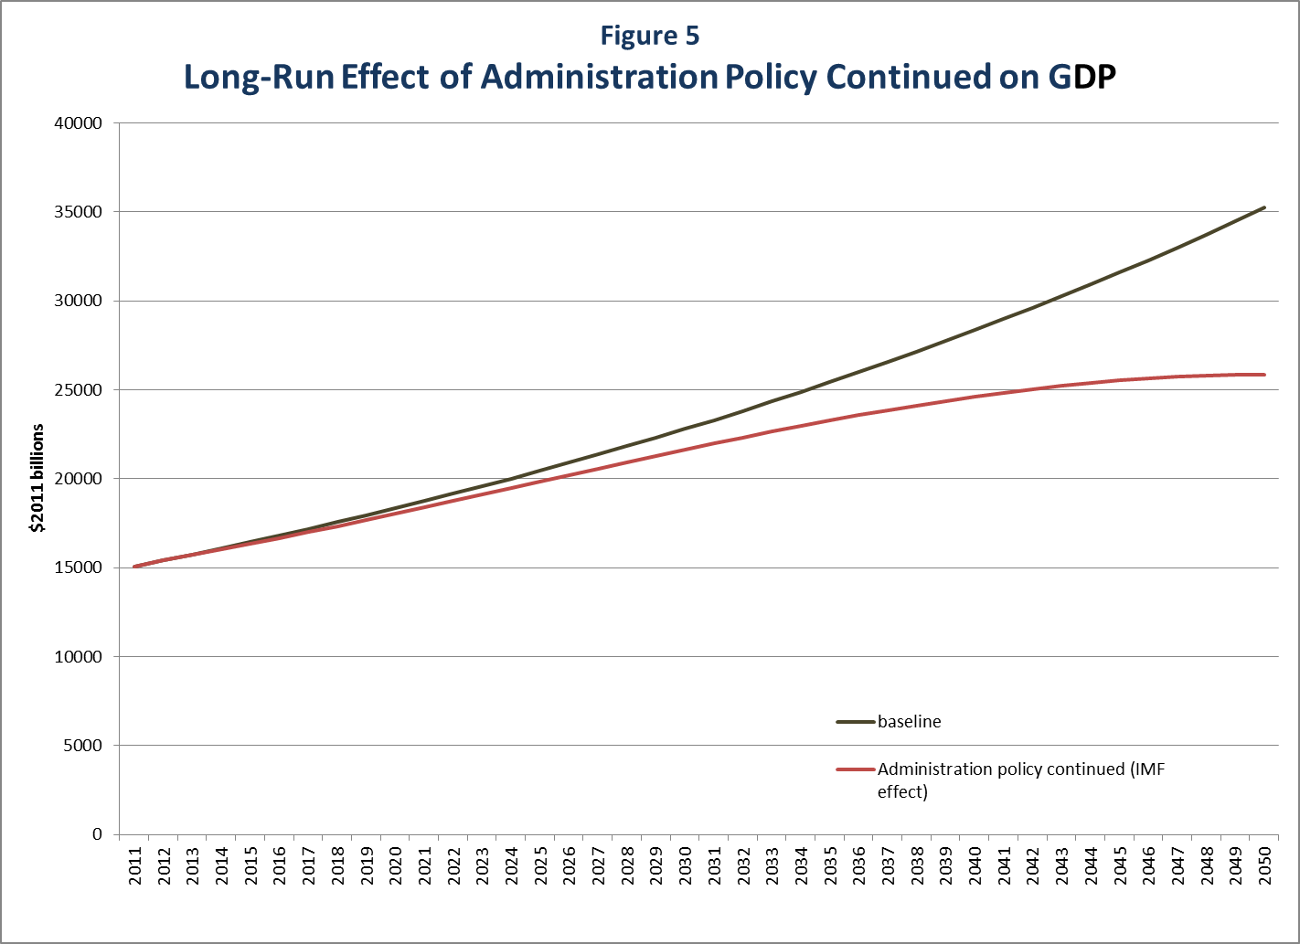
The IMF study by Kumar and Woo analyzes the effects of higher debt-GDP ratios in a panel of advanced and developing countries over the past four decades. They estimate that each 10 percent increase in the debt-GDP ratio reduces the growth rate by 0.17 percent.
The negative effect on GDP grows and, by 2050, the higher debt ratio brings growth to a halt. The level of GDP is 30 percent lower than if the debt had not soared and the policies had not continued. That’s most of a generation of per capita income gains wiped out or, put another way, it is as large as the gap between American and lower Western European per capita incomes. Even at half this size, the damaging effect of debt accumulation on growth is enormous.
If the Administration policies, which, in part, reflect inherited spending commitments and tax rules, and notably do not reform Social Security and Medicare, were altered and the debt-GDP ratio permanently stabilized or, better yet, gradually decreased, the harmful effects would be correspondingly attenuated.
Failing to rapidly begin bending the long-run debt-GDP curve down risks a growth disaster, whose severity could be much worse than the recent deep recession and tragically anemic recovery. Left unchecked, it eventually risks a lost generation of growth, a long-run growth depression. The economic “gain” from the political “pain” of seriously reforming entitlement cost growth is therefore enormous.
Recent research suggests the short-run impact of more government spending is likely to be small or even negative, conversely for cuts, if the debt-GDP ratio is high, it occurs during expansions not recessions, is on non-military purchases, the economy has flexible exchange rates, and/or people expect higher taxes once the Fed exits the zero lower bound on interest rates. All apply to the current United States. So the spending reduction this year from the sequester, only about one quarter of one percent of GDP in outlays anyway, is unlikely to be a major macroeconomic event. Specific dislocations can be minimized by giving agencies even more flexibility in making cuts.
Recent research also reveals fiscal consolidations in OECD countries since WWII that stabilize the budget without recession averaged $5-6 of actual spending cuts per dollar of tax hikes. Spending cuts, especially in entitlements and transfers, were far less likely to cause recessions than tax increases and in some cases increased growth. A dozen recent studies in peer-reviewed journals, including one by president Obama’s first CEA Chair, unanimously document the negative effects on the economy of higher taxes. Since the American economy differs in some ways from these other cases – it comprises over one-fifth of the world economy, interest rates are already low, the dollar is the global reserve currency, and many countries are consolidating simultaneously -- we should be cautious about claiming too much for the short-run benefits of fiscal consolidation.
An economically balanced deficit-reduction program is $5 actual, not hypothetical, spending cuts per dollar of tax hikes. In summary, gradually consolidating the budget by slowing spending growth, minimizing both tax hikes and the impacts on military spending, is the economically soundest course of action.
CBO projects annual federal spending will increase by $2.4 trillion to $5.9 trillion in a decade, or by two-thirds, even if the $110 billion annual sequester or its equivalent stands. Continued delay in spending control to avoid even minor potential economic impact leaves a long boom as the only time to control spending. But a long boom is far less likely if we don’t control our debt. Indeed, the latest research suggests our debt-GDP ratio may be on the verge of a tipping point. Beyond that point, interest rates could unexpectedly rise quite rapidly, which would require a shift to a large, lengthy, politically untenable, primary budget surplus, or risk a sovereign debt crisis.

One successful example of spending control occurred in the mid-1990s under President Clinton and a Republican Congress, but more commonly, as in Washington and many states in the 2000s, the opposite occurs: a boom brings a surge in revenues and politicians are anxious to spread the spending far and wide. Ideally, spending reductions would be phased in as the economy recovers, but it is difficult to make a convincing case that they will indeed occur, given the political economy of the budget, the history of most previous budget agreements and the inability of one Congress to bind the next. While it would be better to credibly phase in the spending reductions as the economy recovers, if that is not possible, it is better to implement the sequester than to perpetually delay spending control.
I thus conclude that the policy priorities should be:
- Medium-run fiscal consolidation and tax reform, as described above, enacted as soon as possible, and difficult to reverse, but phasing in gradually as the economy recovers.
2) Long-run entitlement reforms that minimize work and saving disincentives while reducing subsidies to the well-off. For Social Security, the best avenues are altering its indexing and possibly higher retirement age, while maintaining the early retirement option, again phased in gradually. For Medicare, this means greater competition and more means-testing, e.g. graduated, subsidies to purchase coverage.
3) Budget reform: making programs more effective by eliminating, consolidating and modernizing, e.g. for job training; replacing some of the 40% of the federal civilian work force retiring in the next 10 years with technology, one-stop-shopping; IT spending reform; better balancing the need for temporary economic and humanitarian support with incentives to return to work in transfer programs.
4) Far more predictable and permanent fiscal and monetary policies which are rules-based, i.e., follow clear, predictable guidelines with prescribed limits, except in extreme emergencies such as war and recession. Start by eliminating endless use of temporary tax rules and new spending programs.
5) The policy steps outlined in 1-4 above would be strongly reinforced with international trade liberalization, sensible regulatory reform and human capital policy reform.
Chairman Brady, Vice Chair Klobuchar, and other members of the Committee, I strongly believe that if policy moved in the direction I have suggested, both short and long-run economic growth and concomitant growth in incomes and employment, would increase significantly.

References
Alesina, Alberto, Silvia Ardagna, 2010. “Large Changes in Fiscal Policy: Taxes versus Spending.” In Jeffrey R. Brown, editor, Tax Policy and the Economy, Volume 24. Chicago, IL, University of Chicago Press.
Alesina, Alberto, Carlo Favero, Francesco Giavazzi, 2012. “The Output Effect of Fiscal Consolidations.” NBER Working Paper #18336. Cambridge, MA, National Bureau of Economic Research.
Auerbach, Alan and Yuriy Gorodnichenko, 2012. "Measuring the Output Responses to Fiscal Policy." American Economic Journal: Economic Policy, American Economic Association, 4(2), 1-27.
Cogan, John F., John B. Taylor, Volker Wieland, Maik Wolters, 2012. “Fiscal Consolidation Strategy.” Stanford, CA, Stanford Institute for Economic Policy Research, SIEPR Discussion Paper No. 11-0115, June.
Greenlaw, David, James Hamilton, Peter Hooper, Frederic Mischkin, 2013. “Crunch Time: Fiscal Crises and the Role of Monetary Policy.” New York, NY: U.S. Monetary Policy Forum.
Ilzetzki, Ethan, Enrique G. Mendoza, Carlos A. Végh Gramont, 2012. “How Big (Small?) Are Fiscal Multipliers? Journal of Monetary Economics (Online). ISSN 0304-3932.
Romer, Christina and David Romer, 2010. “The Macroeconomic Effects of Tax Changes: Estimates Based on a New Measure of Fiscal Shocks.” American Economic Review 101(3), 763-801.
Woodford, Michael, 2011. “Simple Analytics of the Government Expenditure Multiplier”. American Economic Journal: Macroeconomics, 3(1): 1-35.

It presents an intermediate case, between the CBO’s more optimistic baseline and alternative fiscal scenario. I took the Administration’s own projection of deficits and debt, based on the President’s policies continuing, with two modest adjustments: 1) I lowered the growth rate, which was well above the CBO growth rate, to closer to the CBO rate; and 2) I split the difference in the debt effect from the OMB baseline, which is optimistic about the beneficial effects of the Administration’s health care reform on health costs, and OMB’s alternative scenario, with health care costs growing at close to the long-run average excess over GDP. In any event, this is just to get a baseline. The effects of the debt on growth and future incomes would be quite similar with these other baselines.
Just as higher debt ratios can affect the rate of economic growth, the growth rate certainly affects debt ratios. Other factors can affect both debt and growth. So it is no simple matter to clearly identify the causal relationships statistically. While the IMF study deals extensively with reverse causality and endogeneity issues, they are a reason to use alternate studies with somewhat different data and methodologies.
The analogous calculation based on the effect estimated by Carmen Reinhart and Ken Rogoff is over 20% lower GDP. For comparison, the Congressional Budget Office uses its macroeconometric model fit to U.S. data to estimate the effect of debt accumulation consistent with its Alternative Fiscal Scenario. CBO concludes it would cause GNP to decline 13.3 percent by 2037 and then is so large and out of the range of experience, it cannot be calculated thereafter, but presumably is vastly higher. Finally, a simple, textbook constant-returns Cobb-Douglas production function, with a one-third capital, two-thirds labor share of income, when combined with the projected debt accumulation and full crowding out, implies a reduction in output of about 17 percent by 2050, more if the reduced investment slows technology dissemination.

