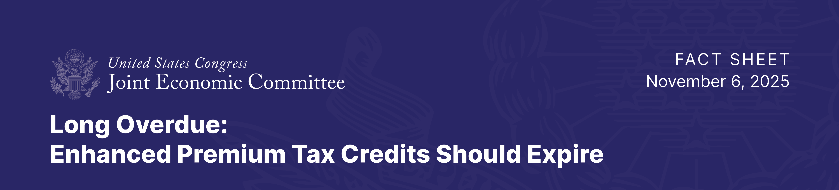

Biden’s COVID Premium Subsidies Outlived Intended Temporary Purpose
Led to Financial Boom for Insurers while providing Limited Reduction in Consumer Costs

Analysis by the Joint Economic Committee finds that the Biden COVID premium subsidies (enhanced premium tax credits) have not only outlived their intended temporary purpose, but evidence indicates that their design, focused on maximizing coverage regardless of cost, reduces pressure on insurers to contain costs.

As a result, the Biden COVID premium subsidies perform poorly as permanent policy: they do more to improve the financial outcomes of large health insurers than to reduce health care costs for Americans.

Implications for Americans:

- Through the Biden COVID premium subsidies, total spending on premium tax credits (PTCs) has more than doubled, far exceeding initial budget projections.

- Biden COVID premium subsidy spending has supported growth in coverage that is either not used by enrollees or susceptible to misuse due to being completely subsidized, making it unclear whether their expiration would truly cause the adverse health outcomes predicted by proponents of extending the PTC.

- Even after the long-scheduled expiration of the Biden COVID premium subsidies, the Affordable Care Act Marketplace, also known as Obamacare, is still expected to receive more federal funding than ever seen before the pandemic.

- The sharp rise in zero-claim enrollment and inflation of gross premiums is evidence that these government subsidies benefit insurers more than consumers.

- For every additional dollar of federal spending on premium tax credits, consumers benefit about 34 cents through lower net premiums, while insurers capture roughly 38 cents.

- The inherent inefficiency of the subsidies drives their increased costs: only one-dollar benefits consumers for every two that are wasted or benefits insurers and intermediaries.

- Maintaining an unsustainable subsidy bubble perpetuates a broken incentive system that deepens market distortions, burdens the American taxpayer, and wastes federal dollars.

Background:

Enhanced PTCs reduce the role of price competition and allow insurers to capture more of the subsidy

- Premium tax credits (PTCs) are directly paid to health insurance companies, who then apply them to consumers’ insurance plans. However, much of the extra government spending on these subsidies is not helping consumers directly. Instead, it is going to insurers and middlemen. This happens for two reasons:
  - More people are signing up but not using their insurance, and
  - Insurers are raising their gross premiums, which subsidies hide from consumers.

- Biden’s COVID premium subsidies have allowed insurers to push premiums even higher by masking rising prices, with many consumers enrolling in plans for $0 per month. After the implementation of the Biden COVID premium subsidies:
  - The share of enrollees that pay $0 or less than $10 in monthly premiums rose sharply to 42 percent.
  - The share of enrollees on HealthCare.gov paying exactly $0 in monthly premiums has more than doubled to 39 percent.

- Government involvement in the health insurance market has caused the masking of cost increases that would otherwise be reflected in consumer-facing premiums.

Surge in Subsidized Zero-Claim Enrollment

- A zero-claim enrollee is someone whose insurance company gets a PTC payment on their behalf, but who does not use their coverage or file any medical claims in a given year. Some of this is normal, healthy people sometimes buy insurance but do not need to use it.

- Since the government increased PTCs in 2021 through the Biden COVID premium subsidies, the number of people not using their coverage has nearly quadrupled.

- Because insurers still get full payment for these people, this ends up costing taxpayer money without providing any real health benefit.

- About 35 percent of enrollees did not file a single claim in 2024, nearly double the rate in 2021.

- Note, other types of insurance, like small group plans, have not seen this same spike in zero-claim enrollment.

- Research also shows a surge in phantom enrollment, people that may be enrolled without their knowledge, a trend enabled in part by zero-premium enrollment.
  - An estimated 6.4 million people may be improperly enrolled

